**MS Office**

**1. Introduction to MS Office (What):**

* **MS Office** is a suite of productivity applications developed by **Microsoft**.
* a comprehensive collection of productivity software applications, developed by Microsoft, that work together to help individuals and organizations create, manage, and share various types of digital information.
* First launched in **1989**, it became the most widely used office software.
* Available for **Windows, macOS, Android, iOS, and Web (Office 365 / Microsoft 365)**.
* Used for creating documents, spreadsheets, presentations, databases, emails, and more.

**🏢 Microsoft Corporation**

* **Founder**:
  + **Bill Gates** (William Henry Gates III)
  + **Paul Allen**
  + Founded on **April 4, 1975** in Albuquerque, New Mexico, USA.
* **Current CEO (2025)**:
  + **Satya Nadella** (since **February 4, 2014**)
  + He succeeded **Steve Ballmer**.

Satya Nadella is the **3rd CEO of Microsoft** after **Bill Gates** and **Steve Ballmer**.

**2. Components of MS Office(Why):**

**2.1 Microsoft Word**

* **Purpose**: Word processing (documents, reports, letters, resumes, etc.).
* **File Extension**: .docx, .doc, .rtf, .pdf
* **Key Features**:
  + Formatting: Font styles, sizes, colors, alignment, bullets, numbering.
  + Page Setup: Margins, orientation, headers, footers, page numbering.
  + Tables & Charts: Create and format tables, insert charts.
  + Mail Merge: Sending bulk letters/emails.
  + Proofing Tools: Spelling, Grammar, Thesaurus, Translation.
  + Collaboration: Track Changes, Comments, Reviewing Pane.
* **Use Cases**: Official documents, books, question papers, CVs, notices.

**2.2 Microsoft Excel**

* **Purpose**: Spreadsheet application for calculations, data analysis, charts.
* **File Extension**: .xlsx, .xls, .csv
* **Key Features**:
  + Worksheets & Workbooks (rows, columns, cells).
  + Formulas & Functions: SUM, AVERAGE, IF, VLOOKUP, HLOOKUP, COUNT, etc.
  + Charts: Bar, Pie, Line, Scatter, Histogram.
  + Data Tools: Sorting, Filtering, Conditional Formatting.
  + Pivot Tables: Summarize and analyze data.
  + Macros: Automating tasks using VBA (Visual Basic for Applications).
* **Use Cases**: Financial reports, marksheets, sales reports, project planning, data visualization.

**2.3 Microsoft PowerPoint**

* **Purpose**: Presentation software.
* **File Extension**: .pptx, .ppt, .ppsx
* **Key Features**:
  + Slides: Text, images, videos, audio, tables, charts.
  + Design & Themes: Predefined templates.
  + Animations & Transitions: For slide objects and slide changes.
  + Slide Show: Presenter view, Rehearse timing, Record slideshow.
  + Collaboration: Co-authoring, comments.
* **Use Cases**: Seminars, lectures, business proposals, project reports.

**2.4 Microsoft Access**

* **Purpose**: Database management system (DBMS).
* **File Extension**: .accdb, .mdb
* **Key Features**:
  + Tables: Store data in rows and columns.
  + Queries: Search and filter data.
  + Forms: User-friendly interface to enter data.
  + Reports: Summarize and print data.
  + Relationships: Link tables (one-to-many, many-to-many).
* **Use Cases**: Inventory, school records, hospital management, employee database.

**2.5 Microsoft Outlook**

* **Purpose**: Email client and personal information manager.
* **File Extension**: .pst, .ost
* **Key Features**:
  + Sending/receiving emails.
  + Calendar: Scheduling meetings, reminders.
  + Contacts & Address Book.
  + Tasks & To-do lists.
  + Integration with MS Teams & SharePoint.
* **Use Cases**: Office communication, meeting schedules, business correspondence.

**2.6 Microsoft OneNote**

* **Purpose**: Digital notebook for notes, drawings, audio.
* **File Extension**: .one
* **Key Features**:
  + Handwritten & typed notes.
  + Insert images, audio, video.
  + To-do checklists.
  + Cloud sync with OneDrive.
* **Use Cases**: Class notes, project ideas, meeting notes.

**2.7 Microsoft Publisher**

* **Purpose**: Desktop publishing application.
* **File Extension**: .pub
* **Key Features**:
  + Templates for brochures, flyers, business cards, newsletters.
  + Advanced text and image formatting.
  + Mail Merge with Word/Excel.
* **Use Cases**: Marketing materials, posters, certificates.

**2.8 Other Tools in Office 365**

* **Teams** – Collaboration & meetings.
* **SharePoint** – File & document management.
* **OneDrive** – Cloud storage.
* **Skype for Business** – Online communication (replaced by Teams).

**3. Versions of MS Office**

* **Office 95, 97, 2000, XP, 2003**
* **Office 2007** – Introduced Ribbon UI.
* **Office 2010** – Backstage view, enhanced collaboration.
* **Office 2013** – Cloud integration.
* **Office 2016** – Improved collaboration.
* **Office 2019** – AI features, inking tools.
* **Microsoft 365 (Cloud-based)** – Subscription model, always updated.

**4. Advantages of MS Office**

1. User-friendly interface.
2. Wide range of applications.
3. Integration between apps (Word ↔ Excel ↔ PowerPoint).
4. Cloud support (OneDrive, SharePoint).
5. Collaboration features (real-time editing).
6. Cross-platform availability.

**5. Disadvantages of MS Office**

1. Paid software (expensive compared to free alternatives like LibreOffice).
2. Requires frequent updates.
3. Advanced features may be complex for beginners.
4. Heavy on system resources.

**6. Real-Life Applications**

* **Education**: Notes, presentations, reports, assignments.
* **Business**: Financial analysis, marketing presentations, client communication.
* **Government**: Database management, letters, reports.
* **Personal**: Budget planning, resumes, personal notes.

**A) Create a folder on C: drive**

**Method 1: Using File Explorer (mouse)**

1. Press **Win + E** to open **File Explorer**.
2. In the left pane, click **This PC** → double-click **Local Disk (C:)**.
3. Right-click an empty area → **New** → **Folder**.
4. Type a name, e.g., **MyWordFiles**, then press **Enter**.

**Quick keyboard way**

1. **Win + E** → go to **This PC → Local Disk (C:)**.
2. Press **Ctrl + Shift + N** to make a new folder.
3. Type **MyWordFiles** → **Enter**.

**B) Save a Word file into that folder**

**Method 1: From Microsoft Word**

1. Open **Microsoft Word** → create or open your document.
2. Press **Ctrl + S** (or go to **File → Save As**).
3. Select **Browse** (or **This PC**) → navigate to **C:\MyWordFiles** (or your Documents path if you used that).
4. In **File name**, type something like **Report.docx**.
5. Click **Save**.

**Method 2: Create the file from the folder**

1. Open **C:\MyWordFiles** in File Explorer.
2. Right-click → **New → Microsoft Word Document**.
3. Name it (e.g., **Notes.docx**) → double-click to open → start typing.
4. Press **Ctrl + S** anytime to save changes.

**Microsoft Word**

**Microsoft Word** is one of the most widely used word processing programs, known for its flexibility and ease of use in creating, editing, and formatting documents. Whether you're drafting a simple letter, preparing a resume, or working on a formal report, **MS Word** provides a rich set of tools to help you produce professional and well-structured content. With features like **text formatting in Word**, **inserting tables and images**, **page layout options**, and built-in templates, users can handle a wide range of document tasks efficiently.

With Microsoft Word, users can easily create everything from **resumes**, **letters**, and **reports** to **essays**, **invoices**, and **brochures**. The software provides robust tools for text formatting, image insertion, page layout, and collaboration, making it the go-to application for document creation.

**🔹 Purpose**

* A **word processor** used for creating, editing, formatting, and printing text-based documents.
* Commonly used for **letters, resumes, books, reports, assignments, CVs, notices, forms, brochures, certificates, and business/legal documents.**

**Microsoft Word Interface**

The Microsoft Word interface is designed for document creation and editing:

* **Title Bar:** Displays the document title and quick access to minimise, maximise, and close options.
* **Ribbon Tabs**: Organised into functional tabs such as Home, Insert, Layout, and Review—each containing related tools and commands.
* **Workspace:** The main area where users type and format the document

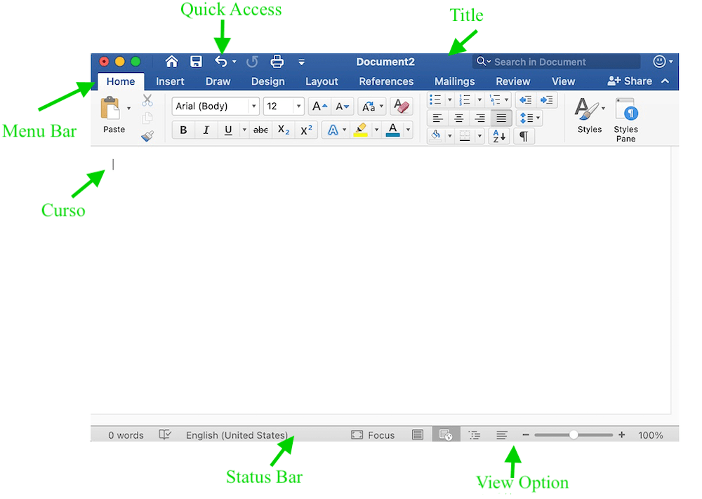

**Microsoft Word Tabs Explained**

* Now let us discuss the tabs and components of the MS Word. Using these tabs, you can perform different types of operations on your documents, like you can create, delete, style, modify, or view the content of your document.

**1. File**

It contains options related to the file, like New (used to create a new document), Open (used to open an existing document), Save (used to save document), Save As (used to save documents), History, Print, Share, Export, Info, etc.

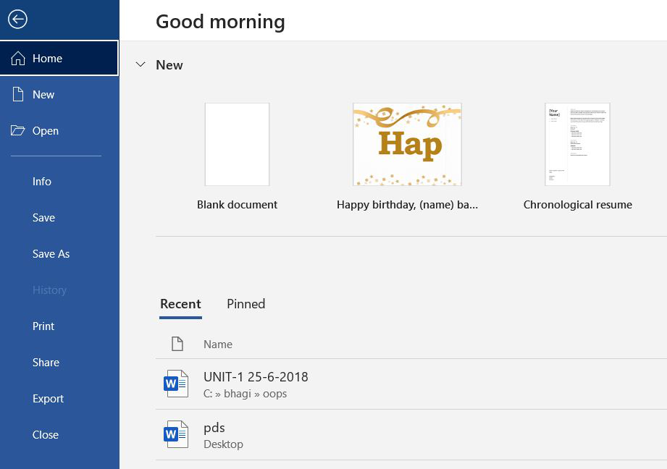

**2. Home**

It is the default tab of MS Word and it is generally divided into five groups, i.e., Clipboard, Font, Paragraph, Style and Editing. It allows you to select the color, font, emphasis, bullets, position of your text. It also contains options like cut, copy, and paste. After selecting the home tab, you will get below options:

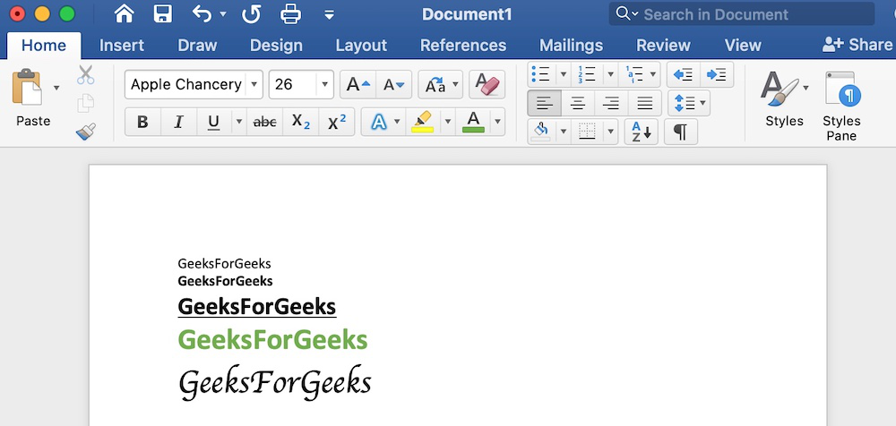

**3. Insert**

Add content such as tables, images, hyperlinks, charts, word art, date/time, header/footer, shapes, text boxes, equations, and more to your document.

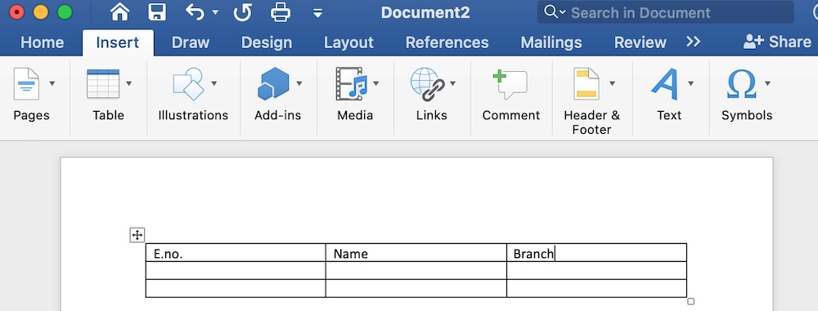

**4. Draw**

It is the third tab present in the menu bar or ribbon. It is used for freehand drawing in MS Word. It provides different types of pens for drawing as shown below:

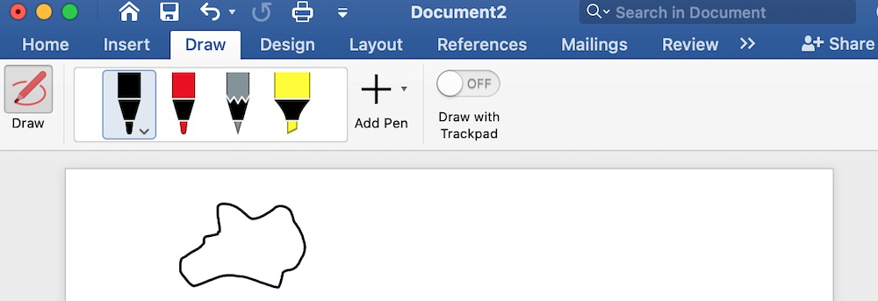

**5. Design**

It is the fourth tab present in the menu bar or ribbon. The design tab contains document designs that you can select, such as documents with centered titles, offset headings, left-justified text, page borders, watermarks, page colour, etc., as shown in the below image:

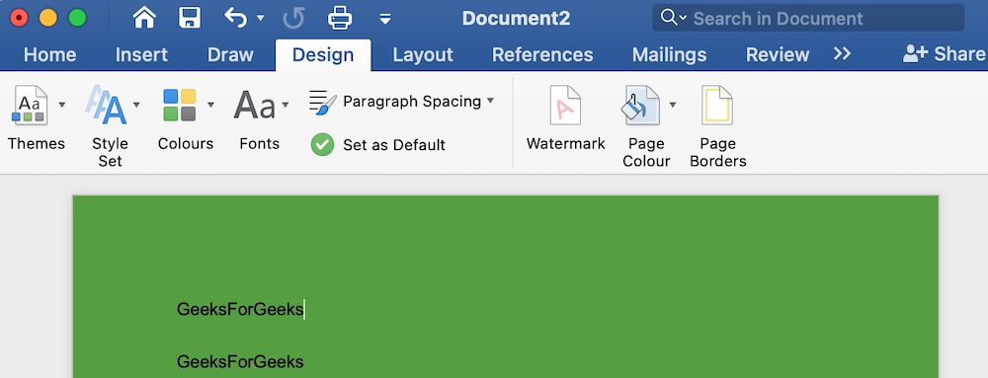

**6. Layout**

It is the fifth tab present on the menu bar or ribbon. It holds all the options that allow you to arrange your Microsoft Word document pages just the way you want them. It includes options like set margins, display line numbers, set paragraph indentation, and lines apply themes, control page orientation and size, line breaks, etc., as shown in the below image:

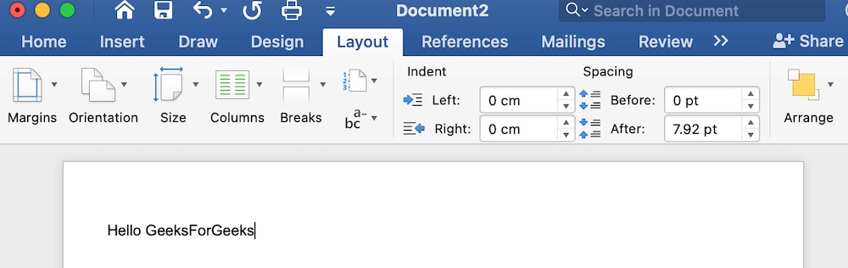

**7. References**

It is the sixth tab present in the menu bar or ribbon. The references tab lets you add references to a document, then create a bibliography at the end of the text. The references are generally stored in a master list, which is used to add references to further documents. It includes options like, Table of Contents, Footnotes, Citations & Bibliography, Captions, Index, Table of Authorities, smart look, etc. After selecting References tab, you will get the below options:

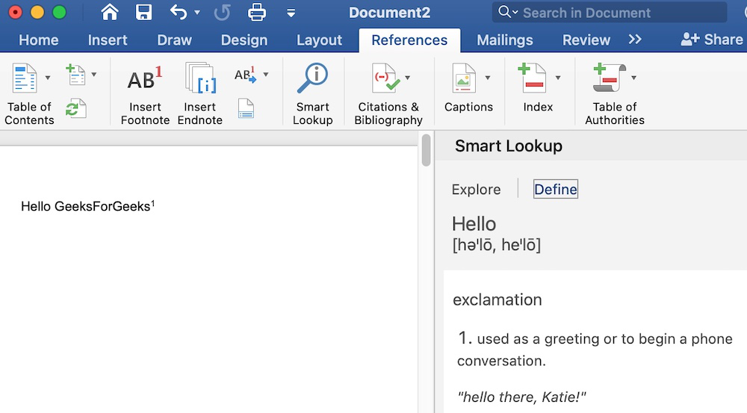

**8. Mailings**

It is the seventh tab present in the menu bar or ribbon. It is a least used tab in the menu bar. This tab is where you would create labels, print them on envelopes, do mail merge, etc. After selecting mailing, you will get the below options:

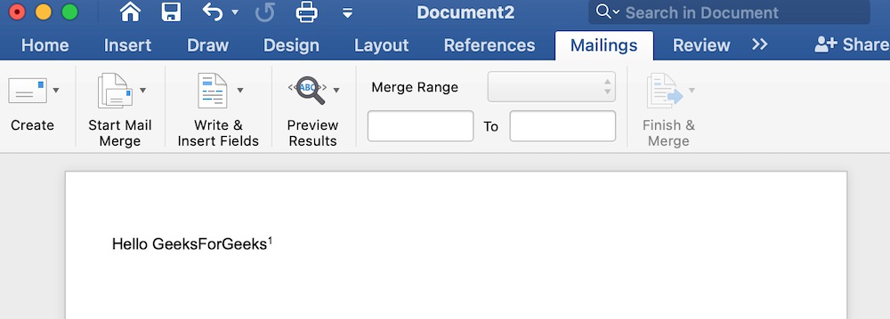

**9. Review**

It is the eighth tab present in the menu bar or ribbon. The review tab contains, commenting, language, translation, spell check, word count tools. It is good for quickly locating and editing comments. After selecting a review tab, you will get the options below:

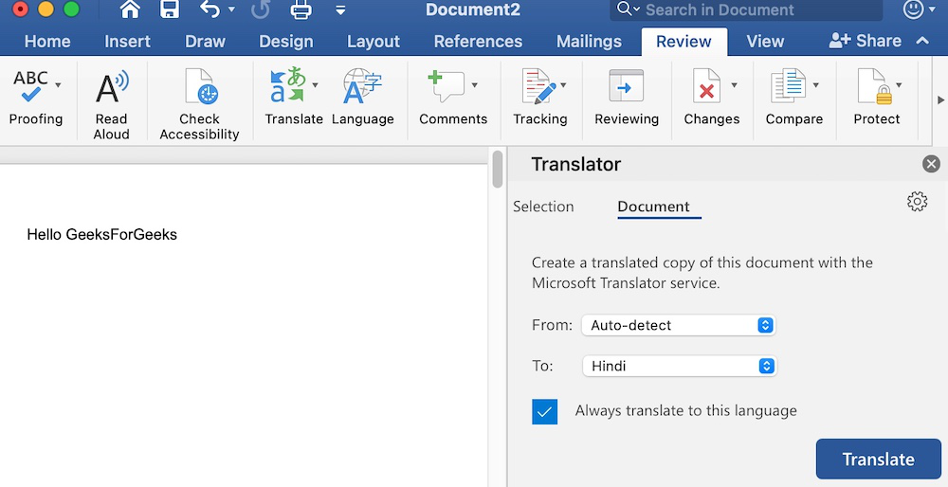

**10. View**

It is the ninth tab present in the menu bar or ribbon. View tab allows you to switch between single page or double page and also allows you to control the layout tools It includes print layout, outline, web layout, task pane, toolbars, ruler, header and footer, footnotes, full-screen view, zoom, etc. as shown in the below image:

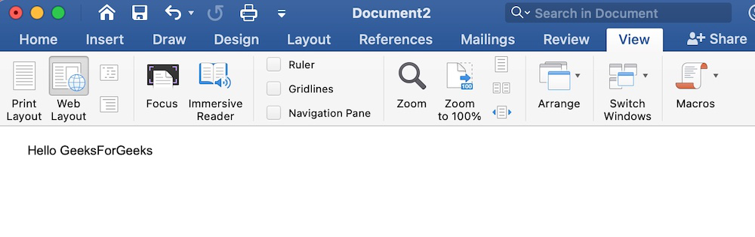

**🔹 File Extensions**

* **.docx** → Default format (XML-based, smaller file size).
* **.doc** → Older Word format (used before Office 2007).
* **.rtf** → Rich Text Format (used for text exchange between programs).
* **.pdf** → Portable Document Format (used for final, non-editable copies).
* **.txt** → Plain text format (no formatting).

**🔹 Key Features (with details)**

**1. Formatting**

* **Font Formatting**: Font style (Arial, Times New Roman), size, bold, italic, underline, highlight, colors.
* **Paragraph Formatting**: Alignment (left, right, center, justify), line spacing, indentation, bullets, numbering.
* **Styles**: Predefined headings, titles, subtitles for consistent formatting.

📌 *Example*: A resume with heading (bold, large font), body text (12pt, justified), bullet points for skills.

**2. Page Setup**

* **Margins**: Space around the page (normal, wide, narrow, custom).
* **Orientation**: Portrait (vertical) / Landscape (horizontal).
* **Paper Size**: A4, Letter, Legal, custom sizes.
* **Headers & Footers**: Information at the top/bottom of every page (titles, author name, dates, page numbers).
* **Page Numbering**: Automatic numbering with styles (1,2,3 or i,ii,iii).

📌 *Example*: A research paper with header → “Chapter Name”, footer → page numbers.

**3. Tables & Charts**

* **Tables**: Organize data into rows & columns. Can be formatted with borders, shading, and styles.
* **Charts**: Inserted from Excel or directly (bar, pie, line, etc.) for visual representation.

📌 *Example*: A student marksheet table with subjects, marks, and total.

**4. Mail Merge**

* Allows creation of personalized letters, labels, or emails using a **data source** (Excel sheet, Access database).
* Steps: Create main document → Select recipients → Insert merge fields → Preview → Finish & Merge.

📌 *Example*: Sending 500 personalized admission letters to students.

**5. Proofing Tools**

* **Spelling & Grammar Check**: Underlines errors in red/blue.
* **Thesaurus**: Suggests synonyms/antonyms.
* **Translate**: Translate text into different languages.
* **AutoCorrect**: Automatically corrects typing mistakes (e.g., “teh” → “the”).

📌 *Example*: Useful while writing an essay to remove spelling errors.

**6. Collaboration Tools**

* **Track Changes**: Records all changes made by editors.
* **Comments**: Reviewers can add notes without changing the document.
* **Review Pane**: Displays suggested changes.
* **Co-Authoring**: Multiple people can edit the same document in real time (Office 365).

📌 *Example*: Team editing a project report.

**7. Graphics & Multimedia**

* Insert **images, SmartArt, shapes, icons, screenshots, 3D models, WordArt**.
* Adjust images with cropping, resizing, and styles.

📌 *Example*: Creating a certificate with a border, logo, and stylish text.

**8. Advanced Features**

* **Table of Contents (TOC)**: Automatically generated from headings.
* **Index & Bibliography**: Used in academic writing.
* **References & Citations**: Insert APA/MLA citations, footnotes, endnotes.
* **Hyperlinks**: Link to websites or other sections of the document.
* **Macros (VBA)**: Automate repetitive tasks.
* **Protect Document**: Password-protection and restricted editing.

**🔹 Use Cases of MS Word**

1. **Education**: Assignments, question papers, study material.
2. **Business**: Letters, proposals, meeting agendas, invoices.
3. **Personal**: Resumes, biodata, notices, invitations.
4. **Publishing**: Books, newsletters, brochures.
5. **Government/Legal**: Circulars, forms, legal documents.

**🔹 Advantages**

* Easy to learn and use.
* Rich formatting and editing features.
* Integration with Excel, PowerPoint, and Outlook.
* Saves time with templates (resume, report, letter).
* Cloud-based collaboration in **Microsoft 365**.

**🔹 Disadvantages**

* Paid software (subscription-based in Microsoft 365).
* Some advanced features (macros, TOC) are difficult for beginners.
* Requires frequent updates and consumes system resources.